Lesson plan 6: Iteration
About the lesson
This lesson introduces students to the concept of iteration and how it can be used to make programs shorter and easier to code. It will focus on identifying patterns in programming code so the amount of code needed can be reduced and loops can be used instead. Students will demonstrate their knowledge of iteration by creating a program that makes use of it.
Learning objectives
By the end of this lesson, students will learn know how to:
- define iteration
- identify patterns in programming code
- use iteration to make programs shorter and easier to code.
National Curriculum
The following subject content from the KS3 National Curriculum is included in this lesson:
- Use two or more programming languages, at least one of which is textual, to solve a variety of computational problems.
- Design, use and evaluate computational abstractions that model the state and behaviour of real-world problems and physical systems.
- Understand simple Boolean logic [for example, AND, OR and NOT] and some of its uses in circuits and programming.
Links
There are links to English and the need for precise instructions that are carried out in order. There are also links to maths with internal angles of 2D shapes and degrees of a circle.
Key terminology
iteration, loop
Teaching and learning activities
Share the objectives for the lesson with students (Slide 2 of Lesson 6 presentation).
Starter
Ask students to write down a sequence of instructions to move a car around a track (Slide 3).
- Students did this task at the beginning of Lesson 1, but there is now a new command they can use, which should enable them to reduce the number of instructions they need to use.
- Students could write the instructions on paper, on a word-processed document, or on a mini whiteboard.
- The idea of this starter is to encourage students to think about how identifying patterns can lead to a reduction in the number of instructions needed.
Example answers
Move 3 squares forward
Turn 90 degrees right
Repeat 2 times
Move 2 squares forward
Turn 90 degrees right
Move 1 square forward
Turn 90 degrees left
Move 1 square forward
Part 1
Recap the three programming constructs and explain the focus is shifting to iteration (Slide 4).
Make sure students understand that although they will be moving on to look at iteration, their programs will still make use of sequencing and possibly also selection.
Explain what iteration is and how it works (Slides 5–6 and page 52).
- Students tend to find iteration difficult to master. This is normally because they make assumptions about what the program should do, rather than following it through.
- There are different types of iteration, but this module focuses on a basic repeat block that will repeat a set number of times.
Show students how iteration works in Scratch (Video 6.1).
Ask students to complete Activity 6.1: Octagon (Scratch 6.1, Pages 52–53/Worksheet 6.1, plus Evidence document 6 and Slide 7).
- Students will need to be given Scratch 6.1. This is a Scratch program that students have to edit.
- There are GIFs in the presentation to show students what should happen when they run their programs. The activity contains an extension activity.

Answers
(See screenshot below and Activity 6.1 solution)
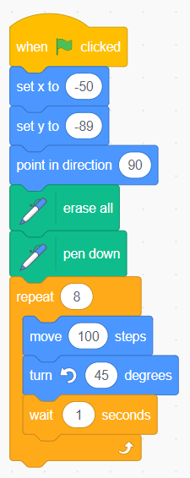

Extension
(See screenshot below and Activity 6.1 Extension solution)
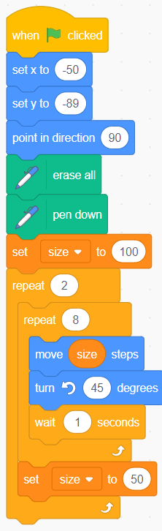
Ask students to complete Activity 6.2: Squares (Scratch 6.2, page 53/Worksheet 6.2, plus Evidence document 6 and Slide 8).
- Students will need to be given Scratch 6.2. This is a Scratch program that students have to edit.
- There are GIFs in the presentation to show students what should happen when they run their programs. The activity contains an extension activity.

Example answers
(See screenshot below and Activity 6.2 solution)
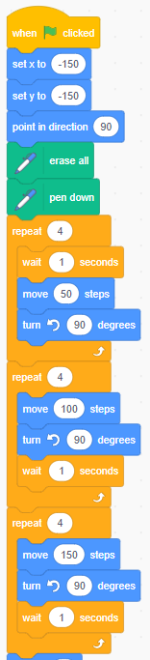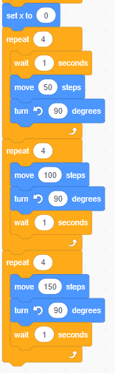

Extension
(See screenshot below and Activity 6.2 Extension solution)
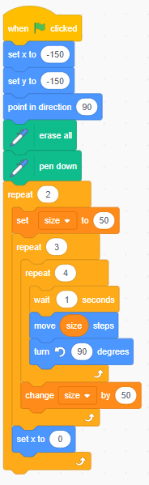

Part 2
Nested iteration can get very confusing, and students often get confused about what each loop is doing, so this part of the lesson is challenging and may not be suitable for all students.
Ask students to look at a program and draw what they think the code draws and then discuss their drawings and how they compare to the actual output (Slide 9).
Possible questions to ask are:
- How many loops are there in the program?
(Answer: Two. They are both repeat loops that repeat three times each.)
- How many times will the turn 120 degrees be executed?
(Answer: Nine times. It repeats three times in the inner loop, which is itself repeated three times in the outer loop: 3 x 3 = 9)
- What does the variable size do in this program?
(Answer: It is changed each time the small loop is executed. It increases by 50, ready for the loop to repeat again. It is used to increase the length of the line being drawn each time the outer loop repeats.)
Explain how nested loops work and how variables are being used to change the size of the line being drawn (Slide 10 and page 53).
- When you have walked students through Slide 10, you could return to Slide 9 and ask students, one at a time, to describe what is happening a line at a time. You could play the role of the cat and draw the diagram on the whiteboard as the students talk you through the program.
- Make sure students understand why the length of the line is set as a variable, size, before the outer loop starts. If the length of the line was set to 50 inside the outer loop, it would be reset to 50 each time the loop is repeated. The line drawn would not increase in length and you would end up with three triangles all exactly the same size.
- It is important that students understand how the code inside the inner loop is repeated nine times.
Ask students to complete Activity 6.3: Spirograph (Page 53/Worksheet 6.3, plus Evidence document 6 and Slide 11).
There are GIFs in the presentation to show students what should happen when they run their programs. The activity contains an extension activity.

Example answers
(See screenshot below and Activity 6.3 solution)
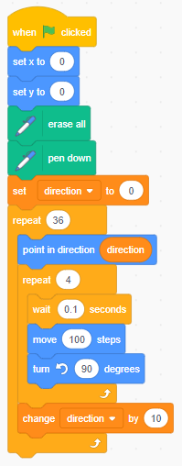

Extension
(See screenshot below and Activity 6.3 Extension solution)
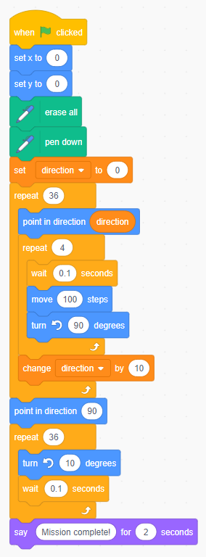
Plenary
Ask students to complete Quiz 6 (Slide 12).
Homework
Ask students to complete any activities they did not finish during the lesson.

Stretch activities
Students who complete the activities in this lesson quickly could experiment with using a range of different shapes to create spirographs and adjusting the other parameters to create new and interesting images. They could combine more than one shape in their spirograph for added effect. This activity could be completed as a mini competition, with the best versions printed out and displayed.
Support activities
Students who struggle with the concept of iteration may find it helpful to add a pause using the wait block at the end of each iteration, so that it is easier to see what has been completed each time the loop is run. When drawing shapes, it will be easiest to start with a simple shape such as a square, before moving onto 2D shapes with more sides.
There are a number of relevant videos available online about using iteration in Scratch, which can be found via a simple search, such as: www.youtube.com/watch?v=dBsHw99Rrio.

